**5. ReactJS-HOL**

My Academy team at Cognizant wants to create a dashboard containing the details of ongoing and completed cohorts. A React application is created that displays the details of the cohorts using React components. You are assigned the task of styling these React components.

**Steps:**

* Restore Packages

Commands: npm install

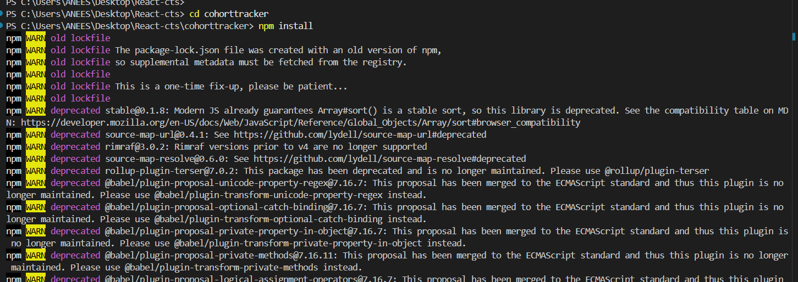

* Create the CSS Module named “CohortDetails.module.css”

**CohortDetails.module.css:**

.box {

width: 300px;

display: inline-block;

margin: 10px;

padding: 10px 20px;

border: 1px solid black;

border-radius: 10px;

}

dt {

font-weight: 500;

}

* Update CoherentDetails.js file:

**CohortDetails.js**

import React from 'react';

import styles from './CohortDetails.module.css';

function CohortDetails(props) {

const status = props.cohort.currentStatus.toLowerCase();

const statusColor = status === 'ongoing' ? 'green' : 'blue';

return (

<div className={styles.box}>

<h3 style={{ color: statusColor }}>

{props.cohort.cohortCode} -

<span> {props.cohort.technology}</span>

</h3>

<dl>

<dt>Started On</dt>

<dd>{props.cohort.startDate}</dd>

<dt>Current Status</dt>

<dd>{props.cohort.currentStatus}</dd>

<dt>Coach</dt>

<dd>{props.cohort.coachName}</dd>

<dt>Trainer</dt>

<dd>{props.cohort.trainerName}</dd>

</dl>

</div>

);

}

export default CohortDetails;

* Run the application:

**Command:** npm start

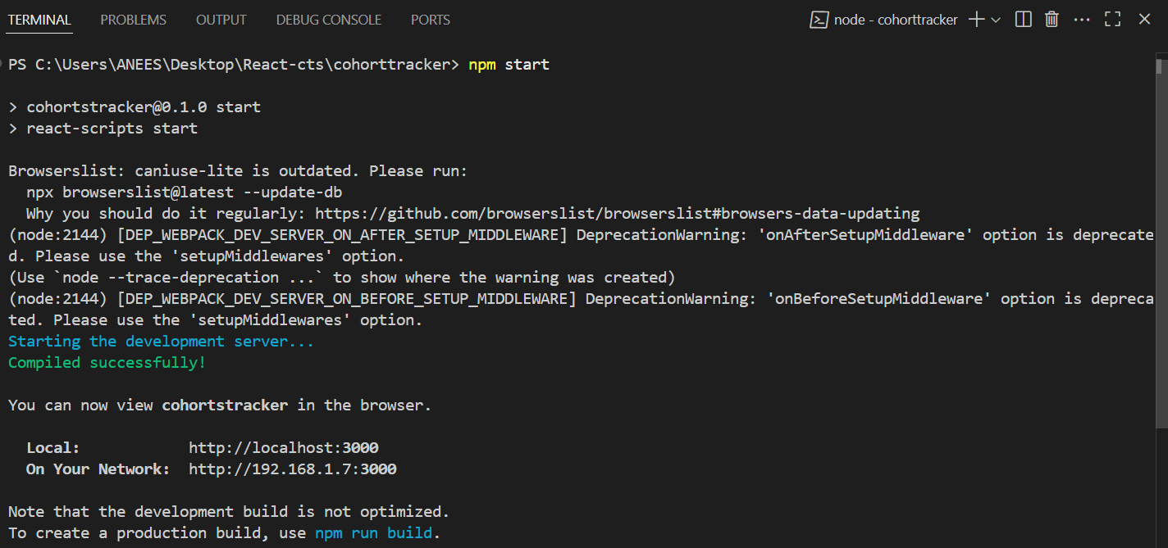

**Output**

